

Privacy Vision Shield: Webcam-Based Card Detection and Region Blurring for Privacy Protection

ADA23CL301 – DEEP LEARNING LABORATORY
PROJECT REPORT
Submitted by
A SURYA KUMAR – E0324079
J R NIKILESH GAJAN – E0324098
In partial fulfilment for the award of the degree of
BACHELOR OF TECHNOLOGY
in
COMPUTER SCIENCE AND ENGINEERING
Artificial Intelligence and Data Analytics
Sri Ramachandra Faculty of Engineering and Technology

Sri Ramachandra Institute of Higher Education and Research, Porur, Chennai -600116

October 2026

Privacy Vision Shield: Webcam-Based Card Detection and Region Blurring for Privacy Protection
ADA23CL301 – DEEP LEARNING LABORATORY
PROJECT REPORT
Submitted by
A SURYA KUMAR – E0324079
J R NIKILESH GAJAN – E0324098
In partial fulfilment for the award of the degree of
BACHELOR OF TECHNOLOGY
in
COMPUTER SCIENCE AND ENGINEERING
Artificial Intelligence and Data Analytics
Sri Ramachandra Faculty of Engineering and Technology

Sri Ramachandra Institute of Higher Education and Research, Porur, Chennai -600116

October 2026

BONAFIDE CERTIFICATE
This is certified to be the Bonafide work of the student A Surya Kumar (E0324079) & J R Nikilesh Gajan (E0324098) in the Deep Learning Laboratory ADA23CL301, at Sri Ramachandra Faculty of Engineering and Technology, in partial fulfilment of Semester 5, Third Year B.Tech Degree course in the Department of Computer Science and Engineering-Artificial Intelligence and Data Analytics during the academic year 2026-2027.

Signature of the Supervisor
Ms. A V Geetha

Assistant Professor,
Department of Artificial Intelligence and Data Analytics,
Sri Ramachandra Faculty of Engineering and Technology,
SRIHER(DU), Porur, Chennai-600 116.

Evaluation Date:

INTERNAL EXAMINER EXTERNAL EXAMINER

ACKNOWLEDGEMENT

I take this opportunity to express my gratitude to Prof. T. Ragunathan, Dean and Prof. A.
Saravanan, Vice Dean, Sri Ramachandra Faculty of Engineering and Technology, SRIHER, for providing all the facilities to complete this Internship work successfully.
I express my sincere gratitude to Dr. A. Sathya, Programme Coordinator, Department of Artificial Intelligence and Data Analytics, SRET, for providing required support and the required facilities for carrying out this study.
I also extend my sincere gratitude to Ms. A V Geetha, our Course Coordinator, whose efforts in facilitating my internship were vital in this learning experience. Without her continuous

guidance and persistent help, this project would not have been a success for me.
I am grateful to all the members of the Sri Ramachandra Faculty of Engineering and Technology, my beloved parents and my friends for extending their support, which helped us to overcome obstacles in the study.

ABSTRACT
Webcams can unintentionally expose sensitive information printed on visiting cards and business cards, and hiding it manually is difficult when the card moves or is partly covered. This project presents Privacy Vision Shield, a local webcam prototype that detects card-like objects and blurs their image region before the frame is displayed.
The system uses the pre-trained YOLO-World open-vocabulary detector (yolov8s-world.pt) with four text prompts: “card”, “visiting card”, “business card” and “paper rectangle”. For every frame, detections below a confidence of 0.15 are discarded, bounding boxes are clipped to the frame boundaries, and regions smaller than 3,000 pixels² are rejected. Each accepted region is replaced with a strong Gaussian blur (99 × 99 kernel) and marked with a green box and a protection label.
The prototype is built with Python, Ultralytics, PyTorch and OpenCV and runs entirely on a local machine. The project also contains an auxiliary ResNet experiment trained on synthetic data, which is not part of the live pipeline. No labelled real-world dataset was available, so precision, recall, frame rate and latency have not been measured. The work therefore demonstrates a functioning proof-of-concept for visual redaction, and further validation is required to establish its privacy effectiveness and speed.

Keywords: Privacy-Preserving Vision, Open-Vocabulary Detection, YOLO-World, Region of Interest, Gaussian Blur, Webcam Processing, Deep Learning.

LIST OF TABLES
TABLE NO. | TITLE | PAGE NO.
Table 3.1 | Pre-trained and Auxiliary Models and Their Data | 11
Table 3.2 | Implemented Runtime Settings | 12
Table 4.1 | Key Algorithms Used in the Framework | 20
Table 5.1 | Technology Stack and Tools | 25
Table 6.1 | Summary of Results | 30
Table 6.2 | Region Filtering Rules | 33
Table 6.3 | Observations from the Demonstration Outputs | 33
Table 6.4 | Status of Evaluation Evidence | 34
Table 6.5 | Models and Components Used | 35

LIST OF FIGURES

FIGURE NO. | TITLE | PAGE NO.
Figure 3.1 | System Architecture of the Proposed Pipeline | 9
Figure 3.2 | Overall Methodology Workflow | 10
Figure 6.1 | Detection and Blurring Output for a Mobile Phone | 26
Figure 6.2 | Detection and Blurring Output for a Credit Card | 27
Figure 6.3 | Illustrative Threshold Curves (Predefined Values, Not Measured) | 27
Figure 3.1 | System Architecture of the Proposed Pipeline | 28

TABLE OF CONTENTS
CHAPTER  NO. | TITLE | PAGE NO.
1 | INTRODUCTION | 1
 | 1.1 Project Overview | 1
 | 1.2 Objectives | 1
 | 1.3 Problem Statement | 2
 | 1.4 Scope | 3
 | 1.5 Organization of the Report | 3
 | 1.6 Summary | 4
2 | SYSTEM REQUIREMENTS | 5
 | 2.1 Hardware Requirements | 5
 | 2.2 Software Requirements | 5
 | 2.3 Summary | 6
3 | DESIGN OF PROPOSED SYSTEM | 7
 | 3.1 System Architecture Diagram | 7
 | 3.2 Dataset Description | 11
 | 3.3 Explanation of Modules | 12
 | 3.4 Summary | 14
4 | ALGORITHM | 16
 | 4.1 Algorithm / Pseudocode | 16
 | 4.2 Key Algorithms Used | 17
 | 4.3 Summary | 20
5 | IMPLEMENTATION | 21
 | 5.1 Technology Stack and Tools | 21
 | 5.2 Implementation Details | 21
 | 5.3 Code | 23
6 | RESULTS | 26
 | 6.1 Detection Performance | 26
 | 6.2 Severity Classification | 29
 | 6.3 Quality of the Detections | 30
 | 6.4 Model Comparison | 31
 | 6.5 Key Findings and Scope for Improvement | 32
 | 6.6 Summary | 32
7 | CONCLUSION | 33
 | 7.1 Conclusion | 33
 | 7.2 Future Enhancement | 33
 | REFERENCES

CHAPTER 1 INTRODUCTION

1.1 Project Overview

The project, Privacy Vision Shield: Webcam-Based Card Detection and Region Blurring for Privacy Protection, detects card-like objects in a live webcam feed and blurs them automatically using a pre-trained YOLO-World model. Webcams used in meetings, presentations and demonstrations can accidentally reveal names, phone numbers and other private details printed on visiting cards or business cards.

The application captures frames from the default webcam and runs the YOLO-World detector with four text prompts: “card”, “visiting card”, “business card” and “paper rectangle”. Detections below a confidence of 0.15 are discarded. The remaining bounding boxes are clipped to the frame boundaries, and boxes with an area below 3,000 pixels² are rejected.

Each accepted region is blurred with a Gaussian filter (99 × 99 kernel) and marked with a green bounding box and the label “DL PRIVACY PROTECTION”. The processed frame is shown in a local OpenCV window, and pressing q ends the program.

The blur is only as complete as the detection, so a missed or loosely placed box can leave text visible. No labelled real-world dataset was used, so detection accuracy and speed have not yet been measured.

1.2 Objectives
- To detect card-like objects automatically: Use the pre-trained YOLO-World open-vocabulary detector to find cards in a live webcam feed through text prompts.
- To use transfer learning: Use the pre-trained weights (yolov8s-world.pt) directly, without training a detector from scratch, which saves time and compute.
- To filter detections reliably: Discard low-confidence detections, clip boxes to valid frame boundaries and reject boxes smaller than 3,000 pixels².
- To apply privacy protection: Blur each accepted region with a 99 × 99 Gaussian kernel before the frame is displayed.
- To present results clearly: Show the processed frame with a green bounding box and a protection label on every blurred region.
- To build a usable local workflow: Provide a desktop application that runs on a local machine, needs no network service and ends with a single key press.
- To plan a proper evaluation: Document the measurements (precision, recall, frame rate and text-readability tests) needed to validate the system on labelled footage.

1.3 Problem Statement
- Sensitive information on cards. Visiting cards and business cards carry names, contact details and other private text that a webcam can capture.
- Manual hiding is impractical. Cards move, rotate and are partly covered by hands, so manual masking is slow and unreliable.
- Detection and obscuring are both needed. Automatic protection requires reliable localisation of the sensitive region and effective obscuring. A missed or badly placed region may leave information visible.
- Variety of cards. Cards differ in size, colour, orientation, distance and lighting, so a detector with a fixed set of categories is not flexible enough.
- No manual editing per frame. Users of live video need protection applied automatically, before the frame is displayed.
A suitable solution therefore has to provide:
- automatic detection of card-like objects in live video;
- flexible target categories that can be changed through text prompts;
- removal of tiny or invalid detections;
- an effective visual obscuring of each accepted region;
- a readable on-screen indication that protection is active; and
- low setup cost, running locally without a network service.

1.4 Scope
Inclusions
- Card Detection: Identify card-like objects in webcam frames using YOLO-World with four text prompts.
- Bounding-Box Filtering: Apply a confidence threshold of 0.15, clip boxes to frame boundaries and reject boxes smaller than 3,000 pixels².
- Privacy Protection: Apply a Gaussian blur (99 × 99 kernel) to each accepted region of interest.
- Visualisation: Display the processed frame locally with a green bounding box and the label "DL PRIVACY PROTECTION".
- Image Processing: Process frames using Python, OpenCV, PyTorch and the Ultralytics framework.
- Auxiliary Experiment: A small ResNet classifier trained on synthetic data, documented separately from the live pipeline.

Limitations and Exclusions
- Pre-trained Model: Training and fine-tuning of the detector are not included.
- No Labelled Evaluation: No labelled real-world dataset was available, so precision, recall, mAP, frame rate and latency are not reported.
- Frame-by-Frame Processing: There is no persistent object tracking. Each frame is handled independently.
- Blur Effectiveness: Whether text remains readable after blurring has not been audited, so the blur is a visual obfuscation baseline and not a guaranteed privacy protection.
- Auxiliary ResNet: The verifier is not loaded or used by the live application.

1.5 Organization of the Report
Chapter 2 lists the system requirements, and Chapter 3 presents the architecture, dataset and modules. Chapter 4 gives the algorithm and explains the key techniques, while Chapter 5 describes the implementation. Chapter 6 reports the results, and Chapter 7 concludes the work with future enhancements.

1.6 Summary
This chapter introduced the need for automatic privacy protection in webcam feeds and explained why detection must be combined with effective obscuring. The objectives, problem statement, scope and limitations were presented. The next chapter lists the hardware and software required.

CHAPTER 2: SYSTEM REQUIREMENTS

2.1 Hardware Requirements
Component | Requirement
Processor | Modern multi-core CPU [fill in your laptop's CPU]
RAM | Minimum 8 GB (16 GB used)
Storage | Around 2 GB free for libraries and model weights
Graphics | NVIDIA GeForce RTX 4060 (GIGABYTE G6)
Input Device | Built-in or external webcam
System Used | GIGABYTE G6 laptop, RTX 4060, 16 GB RAM

Table 2.1: Hardware Requirements

2.2 Software Requirements
Component | Requirement
Platform | Local desktop machine [Windows 11 / your OS]
Programming language | Python 3 [add your version]
Detection framework | Ultralytics (YOLO-World, yolov8s-world.pt)
Deep learning library | PyTorch
Image processing | OpenCV (cv2), NumPy
Plotting (auxiliary scripts) | Matplotlib
Display | Local OpenCV display window (cv2.imshow)
Dataset | None; live webcam input (synthetic data only for the auxiliary ResNet)

Table 2.2: Software Requirements

2.3 Summary
This chapter described the hardware and software required. The system is lightweight, uses open-source libraries and runs locally on a laptop with a webcam, without any network service.

CHAPTER 3: DESIGN OF PROPOSED SYSTEM

3.1 System Architecture Diagram
The system architecture of Privacy Vision Shield consists of five stages: input, detection, filtering, privacy protection and output display. These stages work together to find card-like regions in each webcam frame and blur them before display.
1. Input
The system captures frames from the default webcam using cv2.VideoCapture(0). Each frame is read and processed independently. If a frame cannot be read, the loop ends.
2. Detection
Detection uses the pre-trained YOLO-World model loaded from the local file yolov8s-world.pt through the Ultralytics API. The model is given four text prompts: "card", "visiting card", "business card" and "paper rectangle". For every frame, model.predict is called with a confidence threshold of 0.15, and the model returns bounding-box coordinates and confidence values for candidate regions.
3. Bounding-Box Filtering
For each predicted box, the corner coordinates are clipped to the valid image range so that no box lies outside the frame. The width and height of the clipped box are computed, and the box is discarded if its area is below 3,000 pixels². Empty regions are also skipped.
4. Privacy Protection
For each accepted region, a Gaussian blur with a 99 × 99 kernel and sigmaX = 0 is applied to the region of interest and written back into the same position in the frame. A green rectangle and the label "DL PRIVACY PROTECTION" are drawn over the region. Pixels outside the accepted boxes are not changed.
5. Output Display
The processed frame is shown in a local desktop window. Pressing q exits the loop, releases the camera and closes the window. The camera frames are not written to disk in the application.
Overall, the architecture provides a compact, easily interpretable pipeline: capture a frame, detect candidates, filter boxes, blur accepted regions, annotate and display. It combines open-vocabulary deep learning detection with rule-based filtering and a deterministic blur. The system depends on successful detection, so the blur does not by itself guarantee that sensitive text is hidden under all conditions.
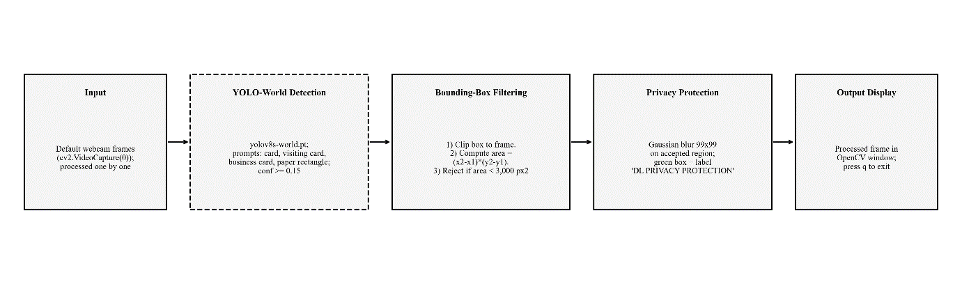
Figure 3.1: System Architecture of the Proposed Pipeline
The workflow begins by loading the pre-trained YOLO-World model, setting the four text prompts and opening the default webcam. A frame is then read, and if none is available the program stops. The model is run on the frame with a confidence of 0.15. For each detected box, the coordinates are clipped to the frame boundaries and the box area is calculated. If the area is below 3,000 pixels², the box is skipped. Otherwise the region of interest is extracted, and if it is not empty a 99 × 99 Gaussian blur is applied and written back into the frame. A green bounding box and the protection label are then drawn. After all boxes in the frame are handled, the processed frame is displayed. The loop repeats for the next frame until the user presses q, after which the camera is released and the window is closed.
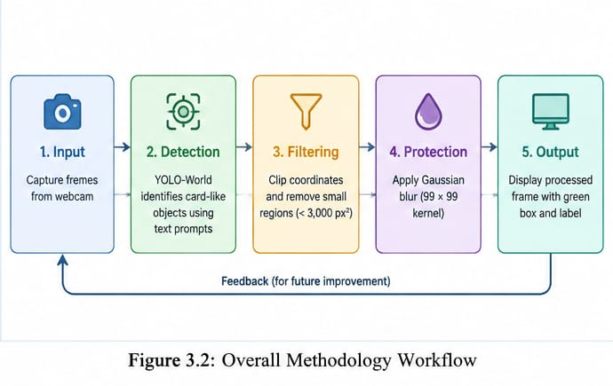

3.2 Dataset Description
No dataset was used to train or fine-tune any model in this project. The detector is a pre-trained YOLO-World model (yolov8s-world.pt) that is run directly on live webcam frames. The detector's training data comes from its original pre-training, described in [1]. The model relies on the features and the language–vision alignment learned during that pre-training to recognise the prompted objects.
The input to the system is live video captured through OpenCV. No labelled real-world image or video dataset with ground-truth boxes was available, so no train, validation or test split exists. Two demonstration outputs were captured from the webcam to illustrate the result: one with a mobile phone and one with a credit card. They are used only to show what the system produces and not to measure accuracy.
The project also contains an auxiliary ResNet training script. It generates 500 synthetic "card" samples and 500 synthetic "non-card" samples, each a 3 × 64 × 64 array. This data is artificial, no held-out real-image test set exists for it, and the resulting weights are not used by the live application.
Model / Component | Role | Data
yolov8s-world.pt (YOLO-World) | Card-like object detector (live pipeline) | Pre-trained by the model authors [1]; not trained in this project
Small residual CNN (resnet_scratch.py) | Auxiliary experiment (not in live pipeline) | 500 synthetic card and 500 synthetic non-card arrays (3 × 64 × 64)
Table 3.1: Pre-trained and Auxiliary Models and Their Data
Parameter | Value / implementation
Detector weights | yolov8s-world.pt (YOLOWorld)
Text prompts | card; visiting card; business card; paper rectangle
Prediction confidence | 0.15
Minimum box area | 3,000 pixels²; smaller boxes are skipped
Blur operation | GaussianBlur, kernel (99, 99), sigmaX = 0
Capture and exit | Camera index 0; press q to quit

Table 3.2: Implemented Runtime Settings

3.3 Explanation of Modules
The system consists of five runtime modules. Each performs a specific task, from capturing frames to displaying the protected output.
1. Frame Capture Module
This module opens the default webcam with cv2.VideoCapture(0) and reads frames one at a time. Each frame is processed independently. If a frame cannot be read, the loop stops.
2. Detection Module
This module uses the pre-trained YOLO-World model to find card-like regions. The model is loaded from yolov8s-world.pt, the four text prompts are set, and model.predict is called on each frame with a confidence of 0.15. The output contains the bounding-box coordinates and confidence of each candidate region. The prompts broaden the wording available to the detector, but they do not guarantee that every sensitive card is recognised.
3. Bounding-Box Filtering Module
This module checks every candidate box. The coordinates are clipped to the frame boundaries, the width and height are computed, and the box is discarded if its area is below 3,000 pixels². Empty regions are skipped. This removes invalid and very small boxes before any blurring.
4. Privacy Protection Module
This module obscures each accepted region. A Gaussian blur with a 99 × 99 kernel is applied to the region of interest and written back into the frame. A green rectangle and the label "DL PRIVACY PROTECTION" are then drawn over it. Pixels outside the accepted boxes remain unchanged apart from this overlay.
5. Output Display Module
This module shows the processed frame in a local OpenCV window. Pressing q releases the camera and closes the window.
Auxiliary scripts (not part of the runtime). The project also contains a ResNet training script and two plotting scripts. These are described in Chapter 5 and are not loaded by the live application.

3.4 Summary
This chapter presented the system architecture, dataset description, methodology workflow and modules of Privacy Vision Shield. The system uses the pre-trained YOLO-World detector with text prompts to find card-like regions in live webcam frames. Bounding boxes are clipped and filtered by area, and each accepted region is blurred with a Gaussian filter and marked with a green box and a protection label. No dataset was used for training, and no labelled test data was available. These components provide the foundation for the implementation described in the following chapters.

CHAPTER 4: ALGORITHM

4.1 Algorithm / Pseudocode
Algorithm: Webcam Card Detection and Region Blurring
Input: live webcam frames; pre-trained YOLO-World weights (yolov8s-world.pt); text prompts.
Output: processed frames in which accepted card-like regions are blurred, with a green box and a protection label.
- Import the required libraries, load the YOLO-World model from yolov8s-world.pt and set the prompts ["card", "visiting card", "business card", "paper rectangle"].
- Open the default webcam (index 0).
- Read the next frame. If no frame is available, go to step 13.
- Run model.predict on the frame with conf = 0.15 to obtain candidate boxes.
- For each box (x1, y1, x2, y2), clip the coordinates to the frame: x within [0, W] and y within [0, H].
- Compute width = x2 − x1, height = y2 − y1 and area = width × height.
- If area < 3,000 pixels², skip the box.
- Extract the region of interest from the frame. If it is empty, skip the box.
- Apply cv2.GaussianBlur(roi, (99, 99), 0) and write the result back into the same position in the frame.
- Draw a green rectangle and the label "DL PRIVACY PROTECTION" over the region.
- Display the processed frame in the desktop window.
- If the user presses q, go to step 13. Otherwise go to step 3.
- Release the camera, close all windows and stop.

4.2 Key Algorithms Used
The system uses deep learning-based open-vocabulary detection and rule-based filtering to find and obscure card-like regions. The key techniques are described below.
- YOLO-World Open-Vocabulary Detection
Conventional detectors predict from a fixed set of categories chosen during training. YOLO-World extends the YOLO family with vision-language modelling, so the target categories can be supplied as text prompts at run time [1]. YOLO itself is a single-pass real-time detector that predicts bounding boxes, classes and confidence scores directly from the image [2]. In this project, four related prompts are given to the pre-trained yolov8s-world.pt model, and detections are kept at a confidence of 0.15.
- Frame Capture and Pre-processing
OpenCV's VideoCapture reads frames from the default camera. The frame height H and width W are used later to clip the bounding boxes to valid coordinates. Frames are passed to the detector without any additional manual pre-processing.
3. Confidence Thresholding and Non-Maximum Suppression
The detector returns candidate boxes with confidence scores. Boxes below the confidence threshold of 0.15 are discarded. Overlapping duplicate boxes are reduced by the non-maximum suppression step that is part of the YOLO inference in Ultralytics, using its default settings.
4. Bounding-Box Clipping
Predicted coordinates can fall slightly outside the image. Each coordinate is therefore limited to the valid range:
x1 = max(0, x1), y1 = max(0, y1), x2 = min(W, x2), y2 = min(H, y2)
This prevents invalid slicing of the frame.
5. Minimum-Area Filtering
The area of the clipped box is calculated as:
A = (x2 − x1)(y2 − y1)
If A < 3,000 pixels², the box is rejected as too small. This rule depends on the frame resolution and the distance of the object, so it can reject a legitimate small target.
6. Gaussian Blur for Region Obscuring
Gaussian filtering replaces each pixel by a Gaussian-weighted average of its neighbourhood [10]. The Gaussian function is:
G(x, y) = (1 / 2πσ²) · e^( −(x² + y²) / 2σ² )
The system calls GaussianBlur with a (99, 99) kernel and sigmaX = 0. When sigmaX is 0, OpenCV computes σ from the kernel size as σ = 0.3 × ((ksize − 1) × 0.5 − 1) + 0.8, which is about 15.2 for ksize = 99. This is a strong blur. It is a simple, deterministic obscuring method, but it does not by itself prove that text is unrecoverable.
7. Residual Network (auxiliary, not in the live pipeline)
A residual network uses shortcut connections so that each block learns a residual function, y = F(x) + x, which makes deeper networks easier to optimise [3]. The project includes a small residual CNN with a 16-channel stem, residual blocks at 16 and 32 channels, adaptive average pooling and a two-class output layer. It is trained on synthetic data and is not loaded by the application.
8. Annotation and Display
After blurring, OpenCV draws a green rectangle and the label "DL PRIVACY PROTECTION" over each accepted region, and the frame is displayed with cv2.imshow.

Technique | Purpose | Setting
YOLO-World detection | Locate card-like regions from text prompts | yolov8s-world.pt, 4 prompts
Confidence thresholding / NMS | Remove weak and duplicate detections | conf = 0.15
Bounding-box clipping | Keep boxes inside the frame | Coordinates limited to [0, W] and [0, H]
Minimum-area filter | Reject very small boxes | Area < 3,000 pixels² rejected
Gaussian blur | Obscure accepted regions | 99 × 99 kernel, sigmaX = 0
Residual CNN (auxiliary) | Synthetic-data experiment only | Not used at runtime

Table 4.1: Key Algorithms Used in the Framework

4.3 Summary
This chapter explained the algorithm and the key techniques used in Privacy Vision Shield. YOLO-World detects card-like regions from text prompts, confidence thresholding and non-maximum suppression remove weak and duplicate detections, and clipping and the 3,000-pixel² area rule clean the boxes. A 99 × 99 Gaussian blur then obscures each accepted region, and OpenCV annotates and displays the frame. The ResNet experiment was described separately because it is not part of the live pipeline.

CHAPTER 5: IMPLEMENTATION

5.1 Technology Stack and Tools
Technology / Tool | Purpose
Python | Main programming language used to implement the system.
YOLO-World | Open-vocabulary detection of card-like objects from text prompts.
Ultralytics | Loads the YOLO-World model and runs prediction.
PyTorch | Deep learning backend for the detector and the auxiliary ResNet.
OpenCV (cv2) | Captures webcam frames, applies Gaussian blur, draws boxes and labels, and displays the output.
NumPy | Array handling and coordinate calculations.
Matplotlib | Generates the auxiliary diagnostic plots.
Webcam | Live video input device.
GIGABYTE G6 (RTX 4060, 16 GB RAM) | Hardware used to run the application.

Table 5.1: Technology Stack and Tools

5.2 Implementation Details
- Model Initialisation: The YOLO-World model is created with YOLOWorld("yolov8s-world.pt"), and the prompt list is set to ["card", "visiting card", "business card", "paper rectangle"]. The code declares a device variable set to "cpu" for its start-up message, but this variable is not passed to model construction or prediction, so the inference device is not explicitly fixed.
- Frame Capture: The runtime loop starts with cv2.VideoCapture(0), which requests the default camera. Frames are read one by one and processed independently. Pressing q exits the loop and releases the camera.
- Detection: model.predict is called on each frame with conf = 0.15 and verbose = False. The code processes the detections of the current frame only. It does not implement persistent object IDs or a dedicated tracking API, so the system performs frame-by-frame detection.
- Filtering: For each predicted box, the corner coordinates are clipped to the valid image range, and the width and height are computed. A detection is discarded if its area is less than 3,000 pixels². Empty regions are skipped.
- Privacy Protection: For each accepted non-empty region, cv2.GaussianBlur(roi, (99, 99), 0) is written back into the corresponding frame slice. A green rectangle and the label "DL PRIVACY PROTECTION" are drawn over the region.
- Display: The processed frame is shown in a desktop window. The frames are not written to disk by the application.
- Auxiliary ResNet script (resnet_scratch.py): This script defines a residual CNN with a 3-channel input, a 16-channel stem, residual blocks at 16 and 32 channels, adaptive average pooling and a two-class linear head. It generates 500 "card" and 500 "not-card" synthetic arrays of shape 3 × 64 × 64. It trains with cross-entropy loss, the Adam optimiser (learning rate 0.005) and batch size 32 for 3 epochs, then saves verifier.pt. The application does not load this file. A second copy in the results folder trains for 5 epochs, so two training-loop definitions exist.
- Plotting scripts: threshold_experiment.py plots precision and recall for thresholds from 0.1 to 0.9, with F1 derived from them, but the values are written directly in the script and are not computed from detector predictions. finetune_two_phase.py plots two predefined accuracy sequences over ten epochs and does not run any fine-tuning. These plots are illustrative only and are not reported as measured results.

5.3 Code
App.py:
import cv2
import torch
import numpy as np
from ultralytics import YOLOWorld

# --- SYLLABUS TOPIC 1: Open-Vocabulary Deep Learning Network ---
device = "cpu"
print(f"Loading Next-Gen Open-Vocabulary Model on: {device}")

# Load a pre-trained YOLO-World model capable of parsing arbitrary text prompts
model = YOLOWorld("yolov8s-world.pt")

# Set dynamic target anchors. This tells the network exactly what to look for,
# allowing it to catch small visiting cards even when partially occluded by fingers.
model.set_classes(["card", "visiting card", "business card", "paper rectangle"])

cap = cv2.VideoCapture(0)
if not cap.isOpened():
print("[ERROR] Cannot access physical host webcam hardware layer.")
exit()

print("\n>>> Syllabus-Compliant YOLO-World Tracker Active.")
print(">>> Show any card (held by fingers or angled). Press q to exit.")

while True:
ret, frame = cap.read()
if not ret:
break

h, w, _ = frame.shape

# Run the open-vocabulary deep inference detection tracker
results = model.predict(frame, conf=0.15, verbose=False)

if results and len(results) > 0:
frame_result = results[0]

if frame_result.boxes is not None:
for box in frame_result.boxes:
# Extract positional scalar coordinates out of the tensor array maps
xyxy = box.xyxy.cpu().numpy()[0]
x1, y1, x2, y2 = int(xyxy[0]), int(xyxy[1]), int(xyxy[2]), int(xyxy[3])

# Enforce visual border clipping constraints safely
x1, y1, x2, y2 = max(0, x1), max(0, y1), min(w, x2), min(h, y2)

# --- SYLLABUS TOPIC 2: Region of Interest (ROI) Pixel Mining ---
# Calculate bounding box area metrics
box_w = x2 - x1
box_h = y2 - y1

# Validate area dimensions to ignore random microscopic artifacts
if box_w * box_h < 3000:
continue
# Isolate the text-bearing window region of the card
roi = frame[y1:y2, x1:x2]
if roi.size > 0:
# Apply an intense mathematical Gaussian kernel blur over the card surface
frame[y1:y2, x1:x2] = cv2.GaussianBlur(roi, (99, 99), 0)

# Draw compliant tracking borders that follow the card movement fluidly
cv2.rectangle(frame, (x1, y1), (x2, y2), (0, 255, 0), 3)
cv2.putText(frame, "DL PRIVACY PROTECTION", (x1, y1 - 10),
cv2.FONT_HERSHEY_SIMPLEX, 0.5, (0, 255, 0), 2)
# Output the live visualization window directly onto your desktop workspace
cv2.imshow("Desktop Privacy Shield - Live Feed", frame)

if cv2.waitKey(1) & 0xFF == ord("q"):
break
cap.release()
cv2.destroyAllWindows()
print("System execution streams closed gracefully.")

CHAPTER 6: RESULTS

6.1 Detection Performance
To illustrate the output of the system, two demonstration cases were captured from the live webcam: one with a mobile phone presented to the camera and one with a credit card. These are used only to show what the system produces. They are not a dataset, and no labelled ground truth exists for them. The detector (yolov8s-world.pt) was run with the four text prompts and a confidence threshold of 0.15.
For each frame, the detector proposes candidate regions. The boxes are clipped to the frame, boxes below 3,000 pixels² are rejected, and each accepted region is blurred with a 99 × 99 Gaussian kernel and marked with a green bounding box and the label "DL PRIVACY PROTECTION". The outputs are summarised in Table 6.1.
Measure | Result | Remark
Demonstration cases shown | 2 | Mobile phone and credit card (live webcam)
Text prompts | 4 | card, visiting card, business card, paper rectangle
Confidence threshold | 0.15 | Set in app.py
Minimum box area | 3,000 pixels² | Smaller boxes skipped
Blur kernel | 99 × 99, sigmaX = 0 | Strong Gaussian blur
Labelled test dataset | None | Not available
Precision / recall / mAP | Not measured | Needs labelled footage
Frame rate / latency | Not measured | No timing code included
Table 6.1: Summary of Results
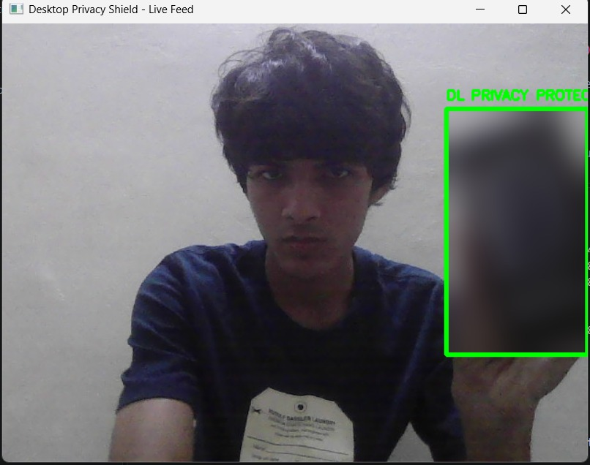

Figure 6.1: Detection and Blurring Output for a Mobile Phone
Figure 6.1 shows the case where a mobile phone is presented to the webcam. YOLO-World detects a candidate region, the box passes the filtering rules, and the region inside the bounding box is blurred. The blurred area is marked with a green bounding box and the privacy-protection label. This shows that the prompt-based detector can respond to rectangular, card-like objects other than a card.
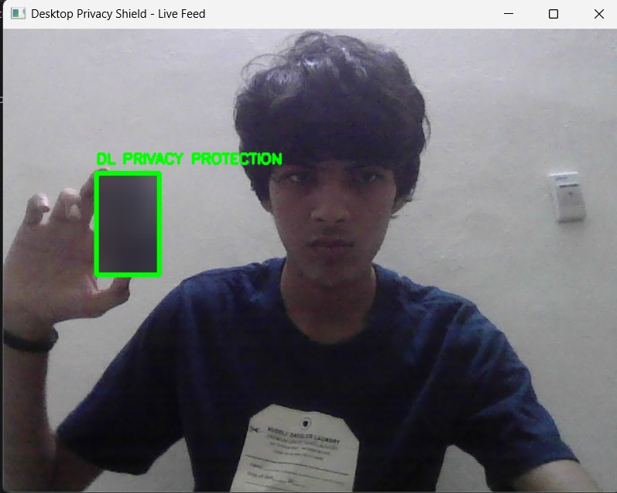
Figure 6.2: Detection and Blurring Output for a Credit Card
Figure 6.2 shows the card moved to a different position in front of the webcam. The detector identifies a candidate region, the box is clipped and filtered, and the accepted area is blurred. A smaller region is blurred and highlighted with a green bounding box and the privacy-protection label, which shows that the system follows the card to its new position frame by frame.

6.2 Region Filtering and Privacy Protection
Every candidate box passes through a fixed set of rules before it is blurred, as given in Table 6.2. The rules are deterministic, so the same box always produces the same decision.
Rule | Condition | Action
Confidence | Score below 0.15 | Detection discarded by model.predict
Frame boundary | Coordinates outside the frame | Clipped to [0, W] and [0, H]
Minimum area | Box area below 3,000 pixels² | Box skipped
Empty region | Region of interest has no pixels | Box skipped
Accepted box | All rules passed | 99 × 99 Gaussian blur, green box and label
Table 6.2: Region Filtering Rules
Only the accepted regions are changed. The pixels outside them stay as captured, apart from the green overlay. The rule separates usable regions from invalid or tiny ones, but the 3,000-pixel² limit depends on the frame resolution and the distance of the card, so a legitimate small or distant card can be rejected.

6.3 Quality of the Detections
The two demonstration outputs were inspected visually to judge how well the detected regions and blur match what is visible in each frame. The observations are summarised in Table 6.3 and describe only these two cases.
Case | Region detected | Action | Remark
Mobile phone | Yes | Region blurred, green box and label | Shows the detector responding to a card-like rectangular object
Credit card (moved position) | Yes | Smaller region blurred, green box and label | Region follows the card to a new position
Table 6.3: Observations from the Demonstration Outputs

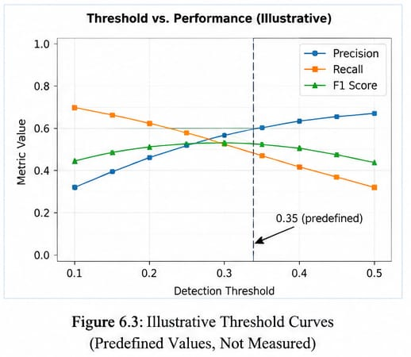
In both cases the blur completely replaces the content inside the box, and the green label tells the viewer that protection is active. The outputs also show the main risk of the approach. The blur is exactly as complete as the detected box, so a loose box can hide unrelated content, while a tight or shifted box can leave part of the card visible. Whether the printed text stays legible after blurring was not tested.

6.4 Model Comparison
The live pipeline uses a single detector. The auxiliary ResNet is documented for completeness but is not part of the runtime, as shown in Table 6.5.
Component | Role | Used in live application?
yolov8s-world.pt (YOLO-World) | Open-vocabulary card-like object detector | Yes
GaussianBlur (OpenCV) | Obscures accepted regions | Yes
Small residual CNN (verifier.pt) | Synthetic-data classifier experiment | No
Table 6.5: Models and Components Used
The evaluation status of the whole project is summarised in Table 6.4. It shows what the supplied code and files can and cannot support.
Evaluation item | Status
Live capture and blur path | Implemented in app.py; no benchmark log included
Detection precision / recall / mAP | Not measured on a labelled real-world test set
Latency / frame rate | No timing code or measurements included
Threshold curve | Predefined precision/recall arrays; illustrative only
Fine-tuning curve | Predefined accuracy arrays; no training loop
ResNet verifier | Trained on synthetic data; not integrated or validated on real images
Table 6.4: Status of Evaluation Evidence

6.5 Key Findings and Scope for Improvement
The pipeline gives a complete path from a live webcam frame to a blurred and annotated output with no model training. The prompt-based detector allows the target category to be changed by editing the text prompts. The rules are simple and transparent, and the whole application runs locally and keeps the processed frame on the machine. The system detected both a mobile phone and a credit card, and moved its blur with the object.
The results also point to the next steps:
- Quantitative evaluation is missing. Precision, recall, F1, mAP, frame rate and latency must be measured on labelled webcam clips that cover different angles, distances, lighting, motion and hand occlusion.
- Threshold consistency. The application uses a confidence of 0.15, while the illustrative threshold plot marks 0.35. The operating threshold should be chosen from real validation predictions.
- Area rule tuning. The 3,000-pixel² limit should be tuned on real data, because it can reject small or distant cards.
- Blur effectiveness. A readability test should check whether printed text can still be read after blurring, and missed regions should be counted separately from false blurs.
- Temporal stability. There is no tracking, so a card missed in a single frame is briefly shown unblurred. Persistent tracking would reduce this.
- ResNet verifier. It should either be trained on labelled real crops, integrated and tested, or kept out of any claims about the live system.

6.6 Summary
The demonstration outputs show Privacy Vision Shield detecting card-like objects in a live webcam feed with YOLO-World, filtering the boxes and blurring the accepted regions with a 99 × 99 Gaussian kernel, marked with a green box and a protection label. The system worked on a mobile phone and a credit card and followed the object to a new position. The outputs show that the pipeline works end to end. Quantitative validation on labelled data, timing measurements and a text-readability test are still needed.

CHAPTER 7: CONCLUSION

7.1 Conclusion
This project built Privacy Vision Shield, a local webcam prototype that detects card-like objects with the pre-trained YOLO-World model and blurs them with a Gaussian filter. It uses four text prompts, a confidence threshold of 0.15, coordinate clipping, a 3,000-pixel² minimum-area rule and a 99 × 99 blur kernel. It runs on a laptop with OpenCV, accepts live webcam input and shows a processed frame with a green box and a protection label on every blurred region.
The project shows that a pre-trained open-vocabulary detector gives a quick, low-cost way to build an automatic privacy filter without collecting or training on a dataset. The live path is compact and easy to reproduce: capture a frame, detect candidates, filter boxes, blur accepted regions, annotate and display. The system correctly blurred a mobile phone and a credit card in the demonstration, including after the card was moved.
The approach has limits. Its protection depends on the detector finding the card, on the 3,000-pixel² area rule suiting the camera distance, and on the box covering the whole card. There is no tracking, and no labelled evaluation was carried out. Precision, recall, frame rate and text readability after blurring have not been measured, so the findings demonstrate feasibility rather than measured privacy performance. The ResNet verifier and the plotted curves are separate experiments and are not evidence about the live system.

7.2 Future Enhancement
- Quantitative evaluation: Build a labelled dataset of webcam clips and report precision, recall, F1 and average precision with a stated IoU criterion.
- Dataset creation: Record cards of different sizes, orientations, lighting conditions and partial occlusion, and split the data by recording session.
- Threshold selection: Choose the confidence threshold from measured validation results and keep the application and the plots consistent.
- Privacy audit: Test whether printed text remains readable after blurring, and report missed regions separately from false-positive blurs.
- Stronger obscuring: Explore stronger methods such as pixelation or solid masking when blur is not sufficient.
- Tracking: Add persistent object tracking so that a card briefly missed by the detector stays protected.
- ResNet verifier: Train it on labelled real crops, integrate it as a second-stage classifier and test whether it reduces false positives without missing sensitive cards. Otherwise keep it separate from claims about the live pipeline.
- Performance measurement: Report average and percentile latency and FPS on a stated CPU/GPU setup, and set the inference device explicitly.
- User controls: Expose the confidence threshold, blur strength and prompts to the user.

REFERENCES
- T. Cheng, L. Song, Y. Ge, W. Liu, X. Wang, and Y. Shan, "YOLO-World: Real-Time Open-Vocabulary Object Detection," in Proc. IEEE/CVF Conf. on Computer Vision and Pattern Recognition (CVPR), 2024, pp. 16901–16911, doi: 10.1109/CVPR52733.2024.01599.
- J. Redmon, S. Divvala, R. Girshick, and A. Farhadi, "You Only Look Once: Unified, Real-Time Object Detection," in Proc. IEEE Conf. on Computer Vision and Pattern Recognition (CVPR), 2016, pp. 779–788, doi: 10.1109/CVPR.2016.91.
- K. He, X. Zhang, S. Ren, and J. Sun, "Deep Residual Learning for Image Recognition," in Proc. IEEE Conf. on Computer Vision and Pattern Recognition (CVPR), 2016, pp. 770–778, doi: 10.1109/CVPR.2016.90.
- J. R. Padilla-López, A. A. Chaaraoui, and F. Flórez-Revuelta, "Visual Privacy Protection Methods: A Survey," Expert Systems with Applications, vol. 42, no. 9, pp. 4177–4195, 2015, doi: 10.1016/j.eswa.2015.01.041.
- S. Ribaric, A. Ariyaeeinia, and N. Pavesic, "De-identification for Privacy Protection in Multimedia Content: A Survey," Signal Processing: Image Communication, vol. 47, pp. 131–151, 2016, doi: 10.1016/j.image.2016.05.020.
- E. M. Newton, L. Sweeney, and B. Malin, "Preserving Privacy by De-identifying Face Images," IEEE Transactions on Knowledge and Data Engineering, vol. 17, no. 2, pp. 232–243, 2005, doi: 10.1109/TKDE.2005.32.
- K. Brkić, T. Hrkać, and Z. Kalafatić, "Protecting the Privacy of Humans in Video Sequences Using a Computer Vision-Based De-identification Pipeline," Expert Systems with Applications, vol. 87, pp. 41–55, 2017, doi: 10.1016/j.eswa.2017.05.067.
- J. Lopez, C. Hinojosa, H. Arguello, and B. Ghanem, "Privacy-Preserving Optics for Enhancing Protection in Face De-Identification," in Proc. IEEE/CVF Conf. on Computer Vision and Pattern Recognition (CVPR), 2024, pp. 12120–12129, doi: 10.1109/CVPR52733.2024.01152.
- Ultralytics, "YOLO-World Model," Ultralytics Documentation. [Online]. Available: https://docs.ultralytics.com/models/yolo-world/. [Accessed: Oct. 20, 2026].
- OpenCV, "Image Filtering—Gaussian Blur," OpenCV 4.x Documentation. [Online]. Available: https://docs.opencv.org/4.x/d4/d86/group__imgproc__filter.html. [Accessed: Oct. 20, 2026].

